1. Install Intellij IDEA 14.1 https://www.jetbrains.com/idea/download/
2. Run Intellij IDEA 14.1 -> Create Maven project
3. Open pom.xml file and add dependencies

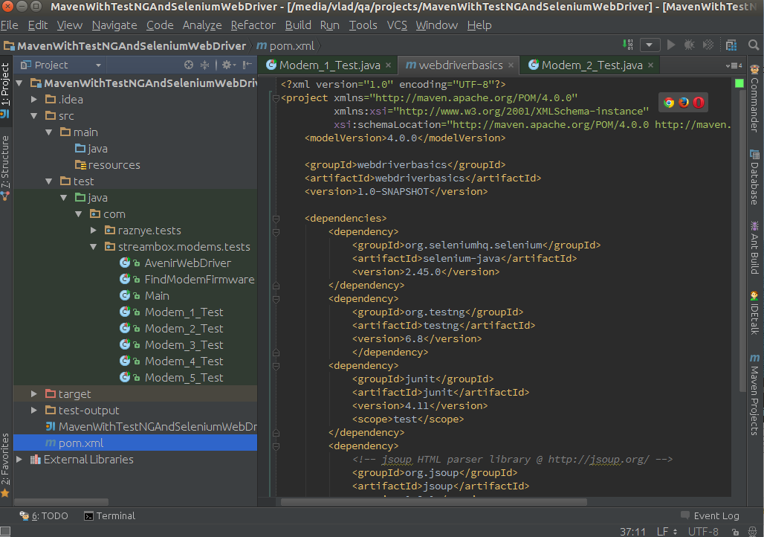

4. How to create runnable JAR file with Maven

By default if you run goal package, a JAR file will be created. But without dependencies and inside META-INF/MANIFEST.MF won't be specified Main-Class.
How to create a runnable Java application? Using Maven assembly plugin.
Add inside pom.xml file:

original .pom file from my project

<build>
<plugins>
<plugin>
<artifactId>maven-assembly-plugin</artifactId>
<configuration>
<archive>
<manifest>
<mainClass>com.streambox.fivemodems.Main</mainClass>
</manifest>
</archive>
<descriptorRefs>
<descriptorRef>jar-with-dependencies</descriptorRef>
</descriptorRefs>
</configuration>
</plugin>
</plugins>
</build>

and inside target directory will be created a JAR file with packaged dependencies

5. Next how to create runnable jar file:

For Intellij IDEA version 11.0.2
File | Project Structure | Artifacts then you should press alt+insert or click the plus icon and create new artifact choose --> jar --> From modules with dependencies.
Next goto Build | Build artifacts --> choose your artifact.

If you see warning message you should follow this steps:

Make sure your MANIFEST.MF is in:
src/main/resources/META_INF/
NOT
src/main/java/META_INF/

5.a Jar It manually

Located your Java classes folder. Jar it with following command in command prompt
1.jar -cf TestJnlp.jar *.*
This will package all the Java's classes into a new jar file, named "TestJnlp.jar".

6. Create JNLP file and put on web server

Create a new Test.jnlp file, content put this
<?xml version="1.0" encoding="utf-8"?>
<jnlp spec="1.0+" codebase="http://10.0.3.93/five_modems/apn_and_phone/" href="Test.jnlp">
<information>
<title>Jnlp Testing</title>
<vendor>Vlad</vendor>
<homepage href="streambox.com" />
<description>Jar File Testing</description>
</information>
<security>
<all-permissions/>
</security>
<resources>
<j2se version="1.7+" />
<jar href="FiveModemsTest.jar" />
</resources>
<application-desc main-class="com.streambox.fivemodems.Main" />
</jnlp>

7. Create keystore

Add a new keystore named "testkeys"
Go to folder where you will put your jar file and run next command

$ keytool -genkey -keystore testKeys -alias jdc

It will ask for a keystore password, first name, last name , organization's unit...etc..just fill them all.

8. Assign keystore to Jar file

Attached newly generated keystore "testkeys" to your "TestJnlp.jar" file
$ jarsigner -keystore testKeys TestJnlp.jar jdc

cd /media/vlad/qa/test
jarsigner -keystore testKeys FiveModemsTest.jar jdc

It will ask password for your newly created keystore

Thats it.

9. How to set up Java Security Settings

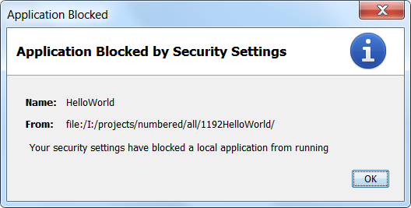

If you have problem to run jar file and if showing security permission requirements than use the next settings:
For Windows
1. Go to Control Panel
2. Double click on Java
3. Open the Security tab
4. Select Medium
5. Click on Apply
6. Restart your web browser
That's it!
Location of the Java Control Panel
Change the setting of the Control Panel
https://www.java.com/en/download/help/jcp_security.xml

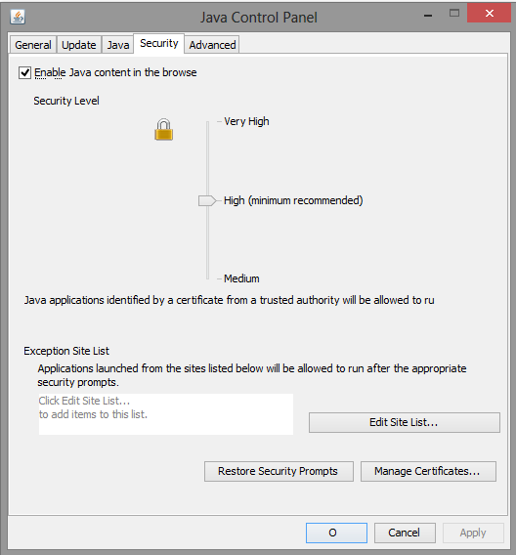

If U have no MEDIUM security level, then U should to add your application to Exception Site List (Java Control Panel/ Security tab).

1) Open your applet in browser and copy file's path.

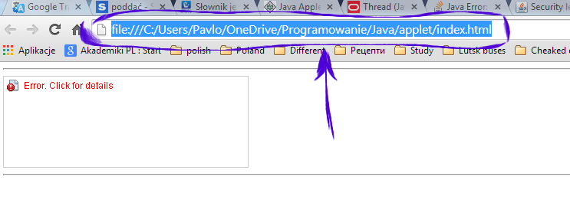

2)Go to Control Panel/Java Control Panel/ Security tab and press Edit Site List button.

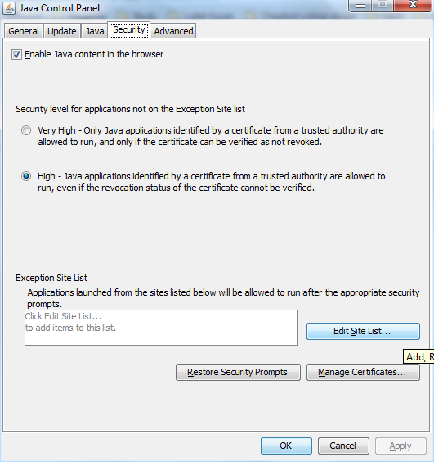

3)Press Add button, insert your path and press Enter.

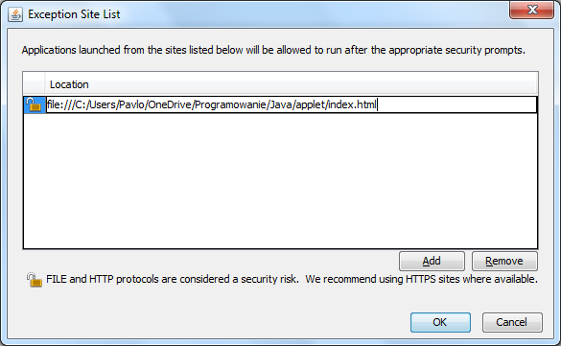

4)Press Continue.

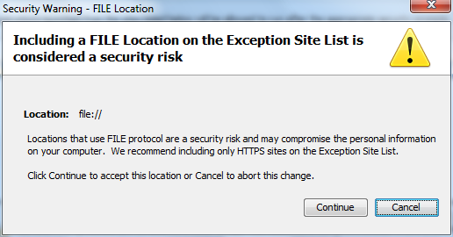

5)Open applet again and don't forget to press RUN on the pup-up window.

Complete fresh installation of Oracle Java SDK (32-bit) on Linux. The installation is correct, the plugin is correctly installed.
Problem
The following error ("Application Blocked by Security Settings") appears when the applet runs inside Firefox:

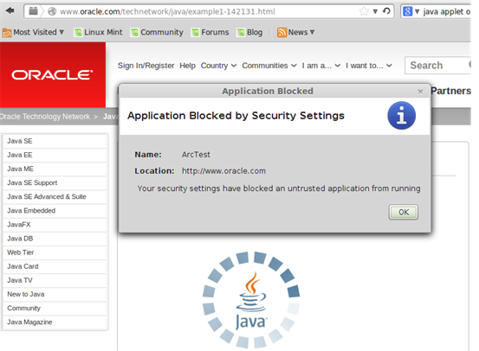

Here are the steps I used:
- Installed Linux mint 16 on VBox: > uname -a Linux me-VirtualBox 3.11.0-12-generic #19-Ubuntu SMP Wed Oct 9 16:12:00 UTC 2013 i686 i686 i686 GNU/Linux
- Cleaned all Java instances.
- Followed instructions to install jdk-7u51-linux-i586.tar.gz on Linux.
- Verified installation > java -version java version "1.7.0_51" Java(TM) SE Runtime Environment (build 1.7.0_51-b13) Java HotSpot(TM) Client VM (build 24.51-b03, mixed mode)
- Verified plugin: > pwd /home/me/.mozilla/plugins > ls -l total 0 lrwxrwxrwx 1 me me 46 Jan 22 02:42 libnpjp2.so -> /usr/lib/jvm/jdk1.7.0/jre/lib/i386/libnpjp2.so
- Verified Java plugin:

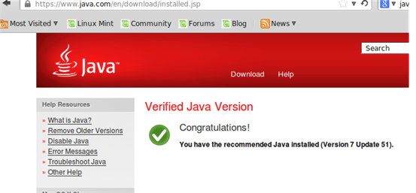
7. Verified Firefox activation:

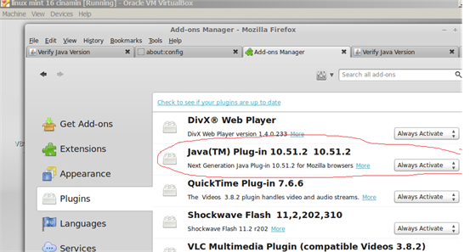
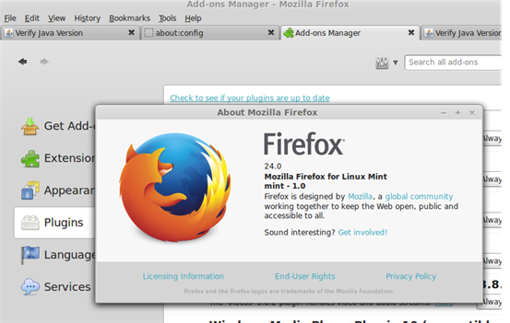

8. Started the Java ControlPanel; set security to Medium:

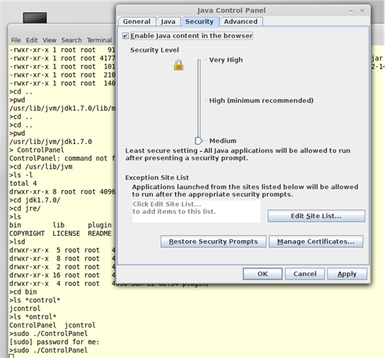
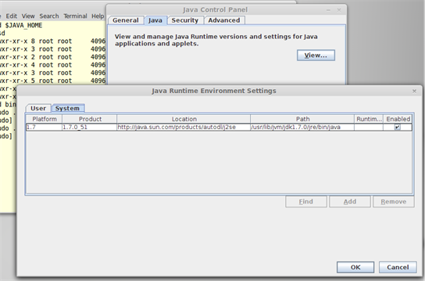

9. Clicked Apply.
10. Restarted Firefox.

If you've manually installed Oracle Java it doesn't show up in the Dash (as far as I know).
1. Open a terminal
2. Execute the following command:
3. /usr/bin/jdk1.8.0_05/bin/ControlPanel
4. Replace /usr/bin/jdk1.8.0_05 by the path of your Java installation.

How to show java plugin console

Java Console is hidden by default.
To change this:
1. First start the Java Control Panel.
2. From the command line run: ControlPanel (if not in PATH, you may have to run something like /usr/lib/jvm/jre1.7.0_51/bin/ControlPanel )
3. Or, choose from the Dash like the screenshot below
4. 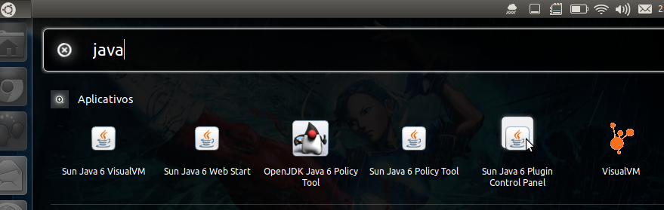
5. In the Java Control Panel go to the Advanced Tab, expand Java Console and choose Show Console. Screenshot below:
6. 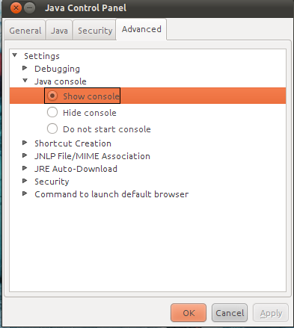
7. Now the console will pop up whenever you execute ANY Java Applet.

Enabling the Java Console for Linux
1. Open the Terminal Window.
2. Go to the Java installation directory.
3. cd /java/jre1.6.0_24 (Change the name of the directory to where you have installed the Java)
4. Open the Java Control Panel. Type: ./ControlPanel
5. You can also open the Java Control Panel through your browser. Launch Netscape or Mozilla. Open the ControlPanel.html file which usually is found in the $JAVA_HOME/jre/ directory
6. In the Java Control Panel, click the Basic tab.
7. Select Show Console radio button.
8. Click the Apply button.

